

Principles of Programming Tutorial Exercise

Exercise Sheet- Week8

1. (**Fahrenheit to Celsius)** Write a program that converts integer Fahrenheit temperatures from 0 to 212 degrees to floating-point Celsius temperatures with 3 digits of precision. Use the formula :

$$celsius = 5.0 / 9.0 * ( fahrenheit - 32 );$$

to perform the calculation. The output should be printed in two right-justified columns of 10 characters each, and the Celsius temperatures should be preceded by a sign for both positive and negative values.

Output:

Fahrenheit Celcius

0 -17.778

1 -17.222

2 -16.667

3 -16.111

4 -15.556

5 -15.000

6 -14.444

7 -13.889

.

.

.

204 +95.556

205 +96.111

206 +96.667

207 +97.222

208 +97.778

209 +98.333

210 +98.889

211 +99.444

212 +100.000

2. (**Scape sequences)** Write a program to test all the escape sequences in Figure 9.16. For the escape sequences that move the cursor, print a character before and after printing the escape sequence so it is clear where the cursor has moved.

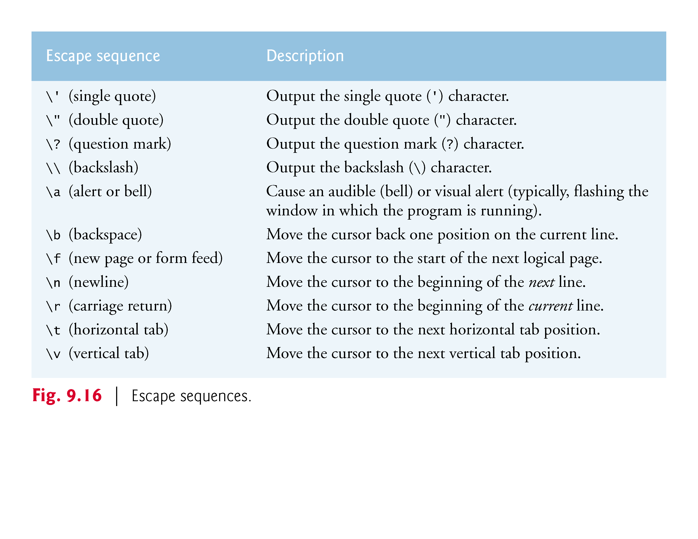

**Output**

The single quote : '

The double quote : "

The question mark: ?

The backslash : \

The bell.

Move cursor back one position on current line. *

Move cursor to start of next logical page. *?*

Move cursor to the beginning of next line. *

*

*ove cursor to the beginning of current line. *

Move cursor to the next horizontal tab position. * *

Move cursor to the next vertical tab position. *?*

1. (**Union**)Create union integer with members char c, short s, int i and long b. Write a program that inputs value of type char, short, int and long and stores the values in union variables of type union integer. Each union variable should be printed as a char, a short, an int and a long. Do the values always print correctly?

Output

Enter a character: A

'A' printed as a character is A

'A' printed as a short integer is -13247

'A' printed as an integer is -858993599

'A' printed as a long integer is -858993599

Enter a short integer: 97

97 printed as a character is a

97 printed as a short integer is 97

97 printed as an integer is -859045791

97 printed as a long integer is -859045791

Enter an integer: 32700

32700 printed as a character is +

32700 printed as a short integer is 32700

32700 printed as an integer is 32700

32700 printed as a long integer is 32700

Enter a long integer: 10000000

10000000 printed as a character is Ç

10000000 printed as a short integer is -27008

10000000 printed as an integer is 10000000

10000000 printed as a long integer is 10000000

1. (**Character constant**)Write a program that determines whether ? can be printed as the character constant '?' rather than the character constant scape sequence '\?' using conversion specifier %c in the format control string of a printf statement.

Output:

This ? can be printed without using the \?